1. **4312211078 – Rizki Purnama Saputra**
2. **4312211065 – Relvin Andika Manda P**
3. **4312201015 – Uci Aulia Putri**
4. **4312211080 – Salma Isra Nabiyya**
5. **4312211087 – Annisa Triwardani**

# PROJECT IDENTITY

Project Title : Mobile Application Baby Monitoring System

Project Owner : Rizki, Relvin, Salma, Annisa, Uci

Project Manager : Agung Riyadi, S.Si., M.Kom

Client : Agung Riyadi, S.Si., M.Kom

|  |  |
| --- | --- |
|  | Final Report |
|  | Product: *Mobile Application*/Hardware/video* |
|  | Demo video /trailer* |
|  | Scientific Poster |
|  | Intellectual Property Rights Document |
|  | Handover Document |
|  | Contest Proposal (optional) |

Outputs :

Approved by,

Batam, 25 Juni 2024

Agung Riyadi, S.Si., M.Kom

NIK. 119221

# LIST OF CONTENT

PROJECT IDENTITY iii

LIST OF CONTENT v

LIST OF FIGURES vi

LIST OF TABLES vii

1. PROJECT-BASED LEARNING PRODUCT viii

1.1 Product Description viii

1.2 Product Design viii

2. PRODUCT IMPLEMENTATION ix

2.1 Product Implementation ix

3. CONCLUSION 1

2.1 Obstacle 1

2.2 Learning Process 1

APPENDIX I – LOGBOOK 2

APPENDIX II – TEAM SCHEDULE 3

APPENDIX III – PROJECT BOARD 4

APPENDIX IV – PRESENTATION SLIDES 6

APPENDIX … – …. 7

# LIST OF FIGURES

# LIST OF TABLES

# PROJECT-BASED LEARNING PRODUCT

## Product Description

Mobile Baby Monitoring System application is an integration between mobile application and IoT System. The idea is a smart crib system that will help parents monitor their babies remotely. The idea comes up with a crying detection mechanism, live video surveillance, and user interface in mobile or web version. Different sensors installed in the crib will check the humidity or temperature of the bed. The surveillance camera will always send the footage of the main IoT program. This app is very useful for parents.

## Product Design

Product design for a mobile application project should have the following design:

* 1. General system description.

Mobile Baby Monitoring System application is an integration between mobile application and IoT System. The idea is a smart crib system that will help parents monitor their babies remotely. The idea comes up with a crying detection mechanism, live video surveillance, and user interface in mobile or web version. Different sensors installed in the crib will check the humidity or temperature of the bed. Surveillance cameras will always send footage of the main IoT program. Based on the existing features, health will always check the baby's condition and alert the parents if an undesirable situation arises. Important Features: This project will reduce the pressure of parents in monitoring baby children. This is a Raspberry Pi-based project. The software language can be Python. Instant application notification system. Analysis of baby's voice and parents' vigilance.

* 1. Functional system requirements.

a. Live Audio and Video Monitoring: The ability to stream live audio and video from the baby's room to the parent's mobile device.

b. Two-Way Communication: Allow parents to speak to their baby through the mobile app, facilitating two-way communication.

c. Remote Camera Control: Enable parents to remotely control the camera (pan, tilt, zoom) to get a better view of the baby's room.

* 1. Use case.

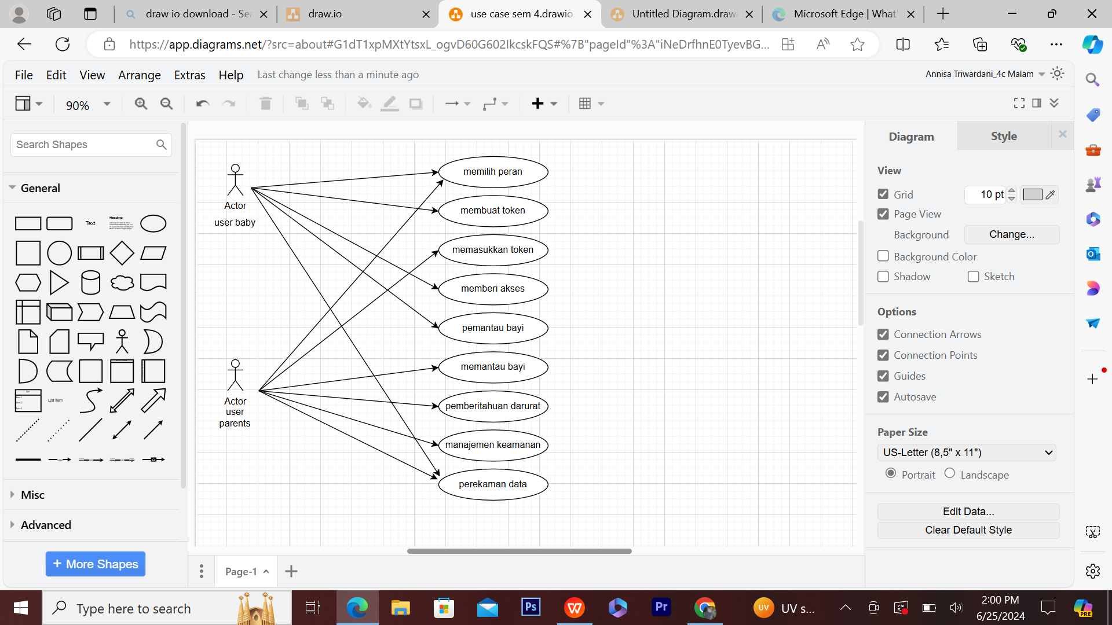

*Use Case*

Figure 1.1

* 1. ER diagram.

+-----------------------+ +-----------------------+

| Perangkat | | Token |

+-----------------------+ +-----------------------+

| ID_Perangkat (PK) | | ID_Token (PK) |

| Jenis | | Token |

+-----------------------+ | Status |

| ID_Perangkat (FK) |

+-----------------------+

* 1. Product interface/architecture design.

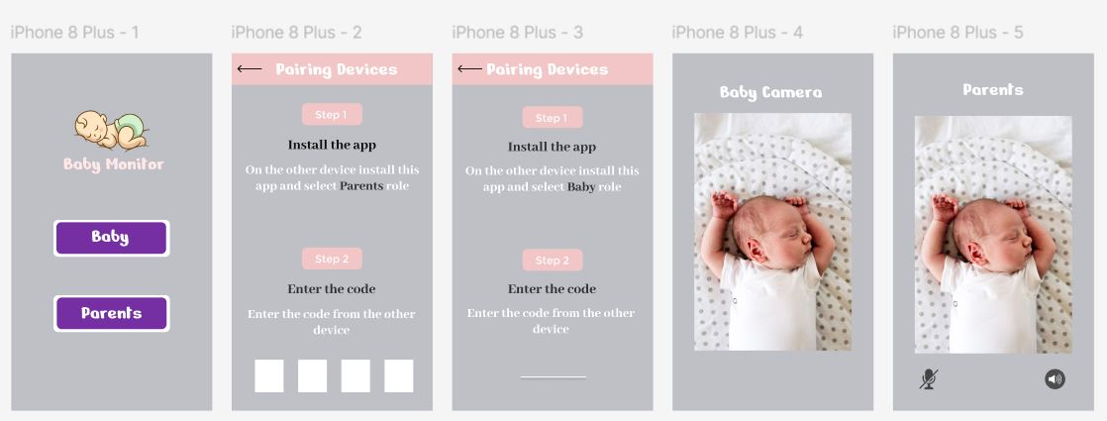

Figure 1.3

* 1. Programming language.

Flutter is an open-source framework used to build responsive and feature-rich user interfaces (UIs). Using the Dart programming language, Flutter allows developers to create apps that run on multiple platforms such as Android, iOS, web, and desktop by using the same codebase. Dart is designed as a modern, efficient, and easy-to-learn programming language, and is optimized for building high-performance applications, especially in the development of complex cross-platform applications.

# PRODUCT IMPLEMENTATION

## Product Implementation

Product implementation for mobile application projects:

1. Implementation for user interface / product design.



Figure 2.1

1. Product testing result

# CONCLUSION

## 2.1 Obstacle

It is quite difficult to find time and place to discuss in the campus area, sometimes there are conflicts with working hours.

Presentation 95%:

The success of this project has reached 95% because the application we made is complete and can be connected to the iot system that we have assembled.

## 2.2 Learning Process

Describe new things and insights gained from working on the PBL project. Then, relate it to the courses you have taken in this semester.

a. Computer System Administration

This course contributes to explaining the basic concepts of computer system administration.

b. Mobile Device Programing

This course contributes to creating user interfaces, integrating with multimedia content such as images, audio or video.

c. Object Programing

Object programming provides a a mechanism to organize data access and manipulate data

d. Multimedia IoT System

This course contributes to the programming of IoT devices, implements several communication methods on IoT devices IoT devices

e. Statisics

This course contributes to generate or create basic concepts of data collection, chance/probability and sampling distribution.

f. General English

We can learn to speak for interaction, namely informal interaction (Greetings and Farewells, Describing Something), and vocabulary.

g. Civic Education

we can explains the importance of national identity, national integration, institutions Republic of Indonesia.

# APPENDIX I – LOGBOOK

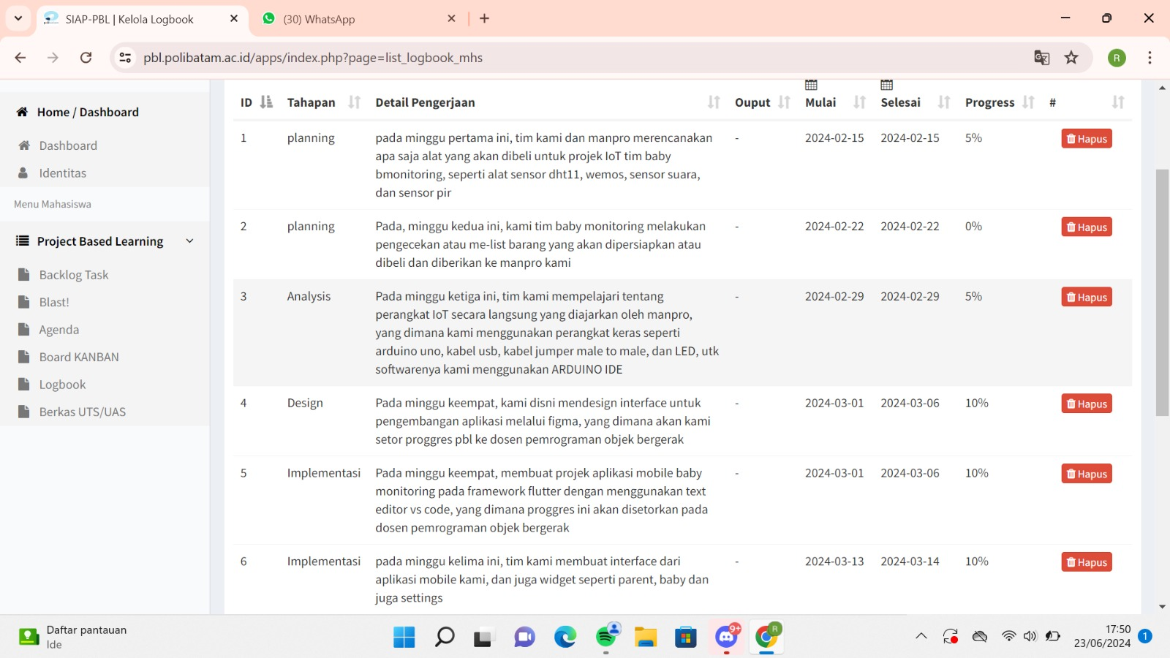

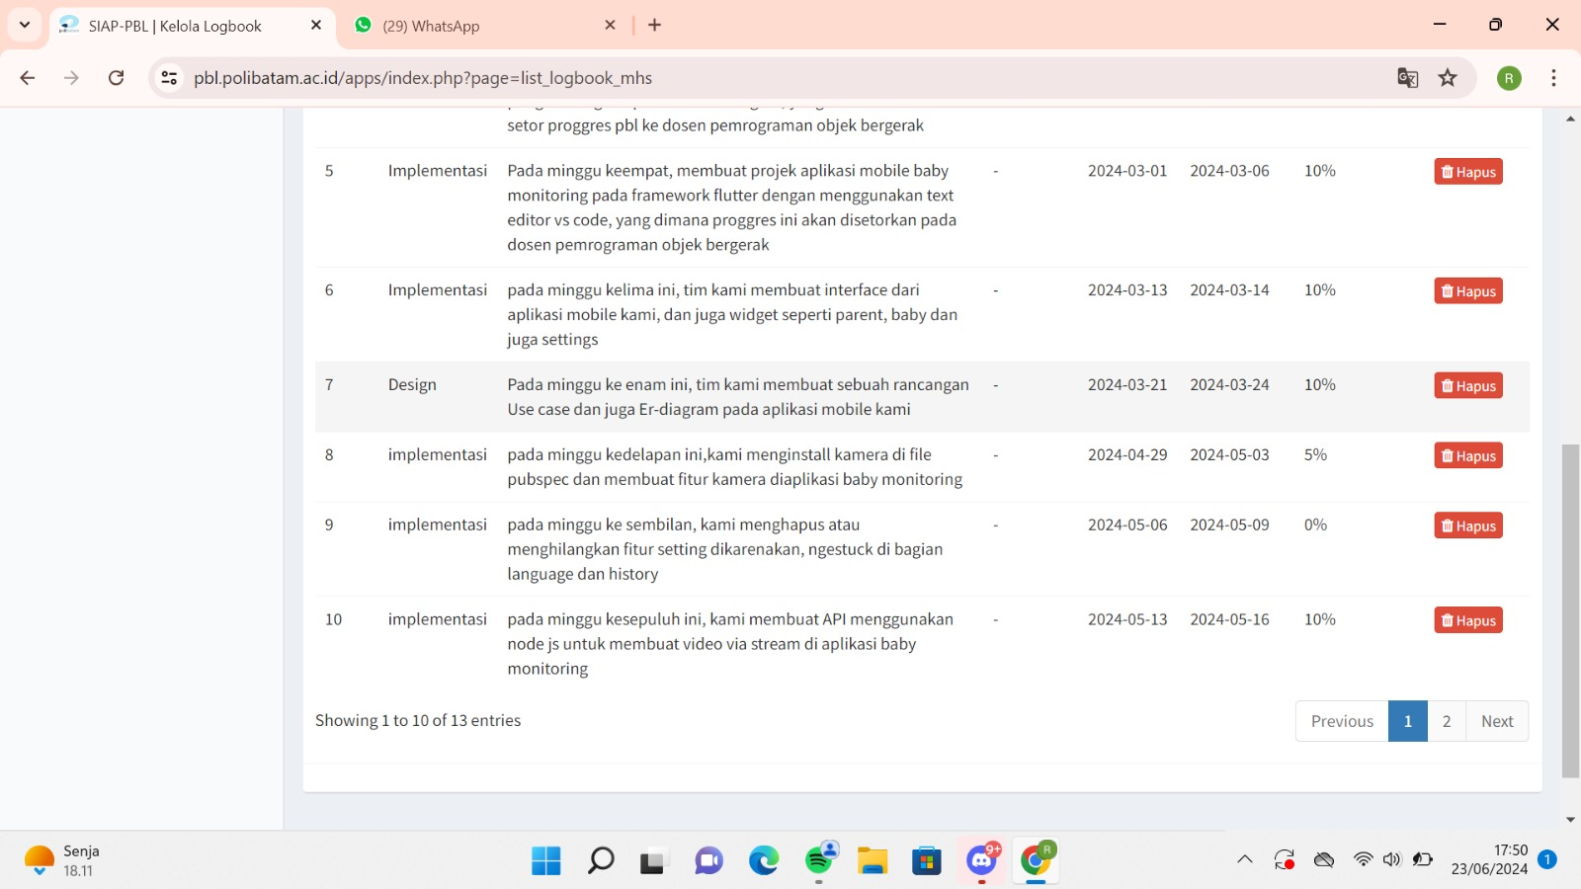

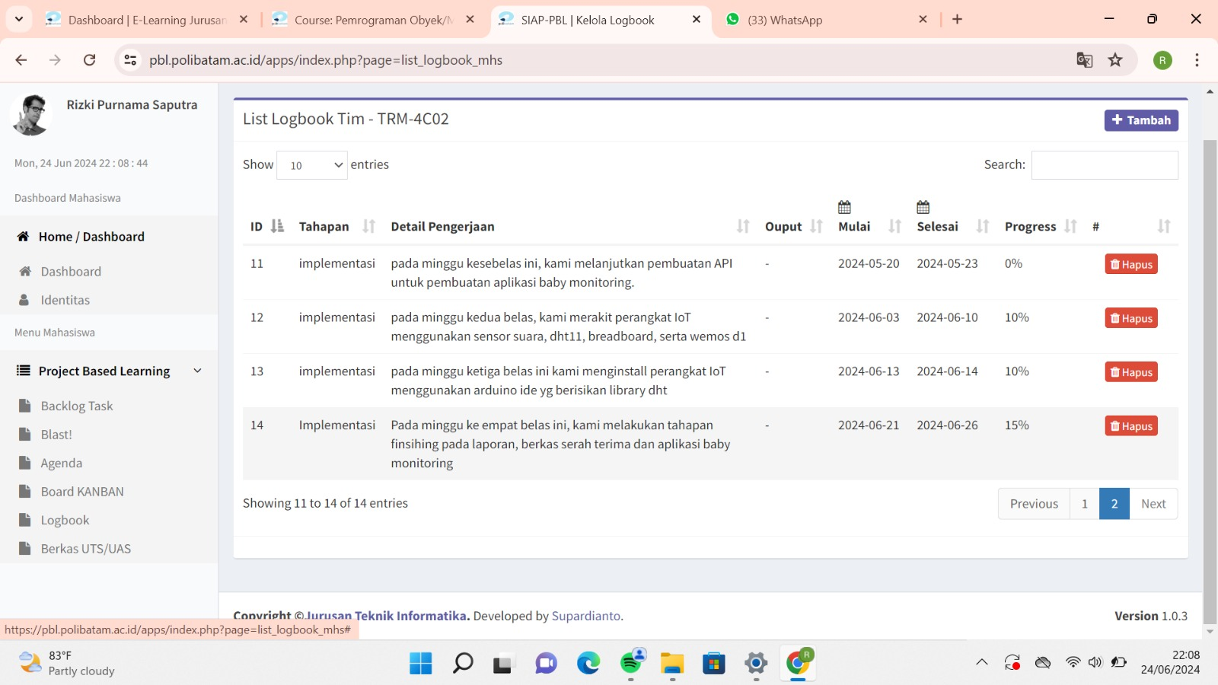

# APPENDIX II – TEAM SCHEDULE

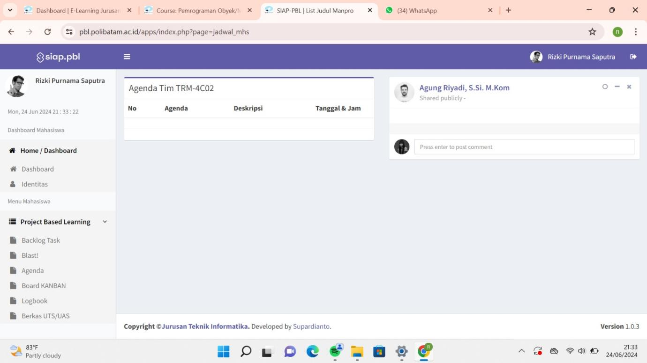

# APPENDIX III – PROJECT BOARD

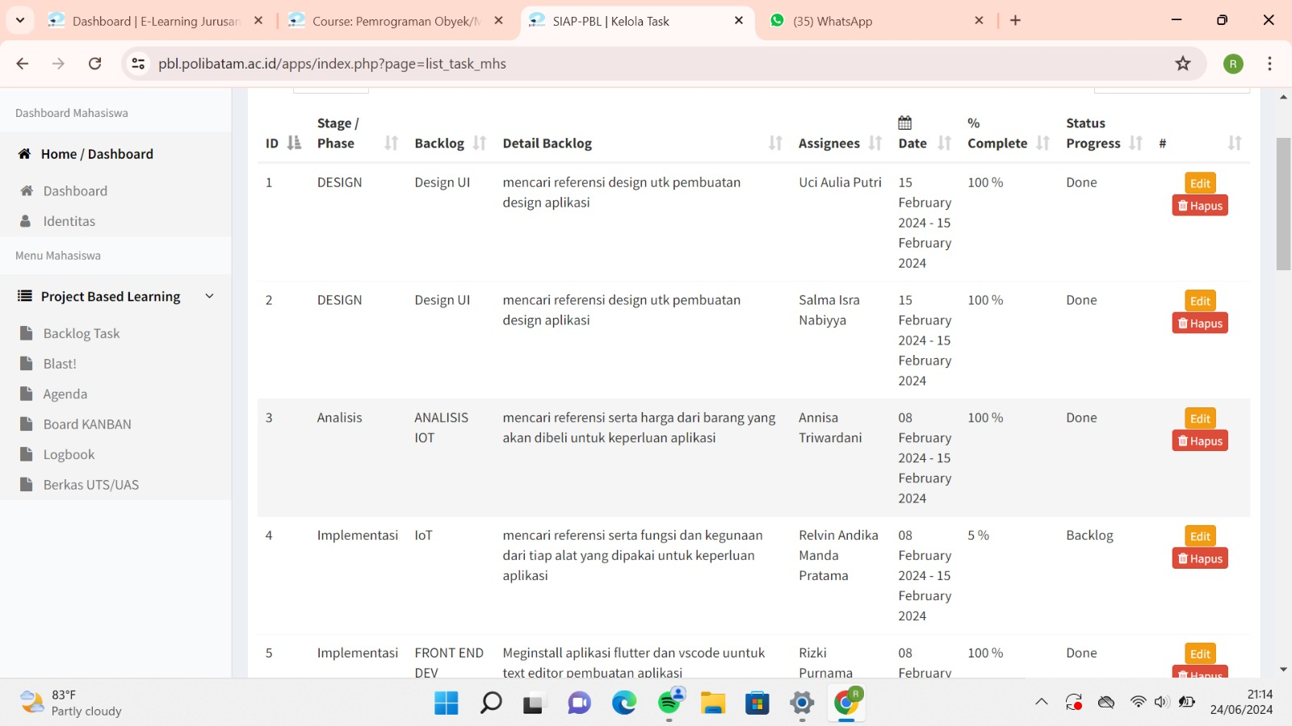

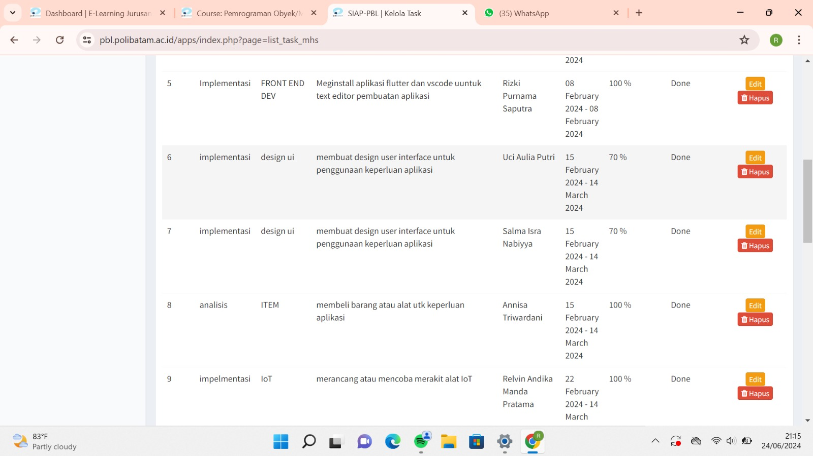

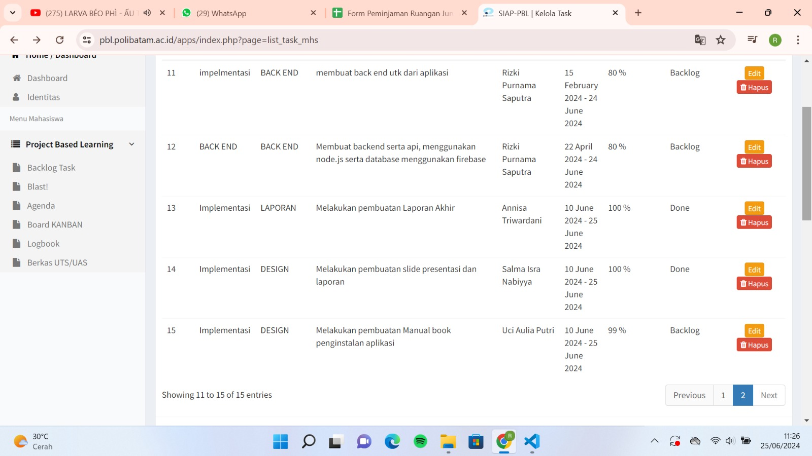

# APPENDIX IV – PRESENTATION SLIDES

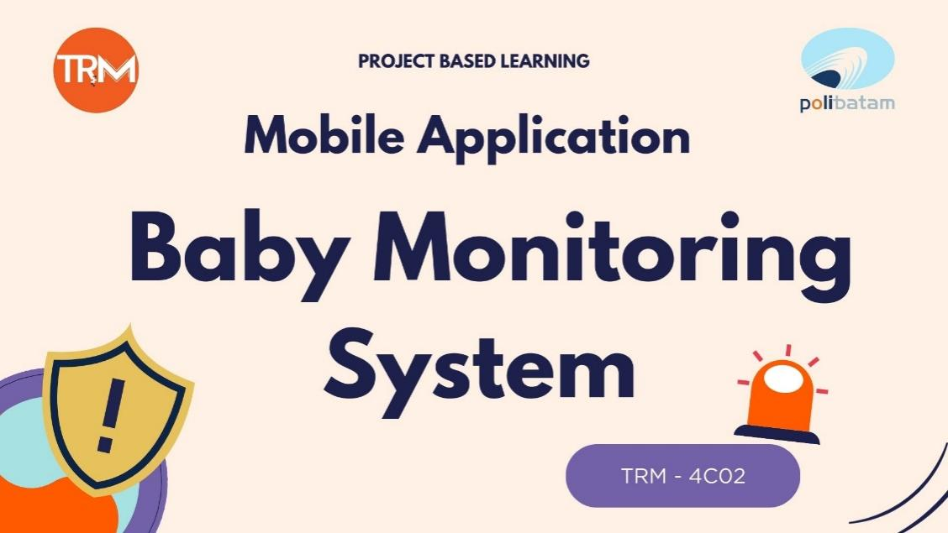

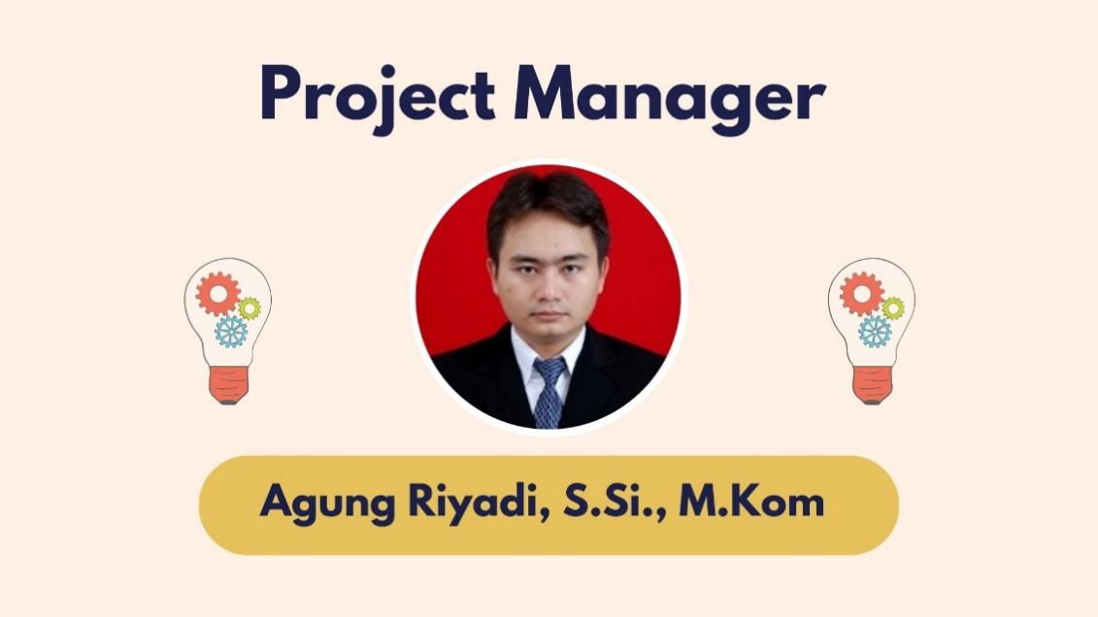

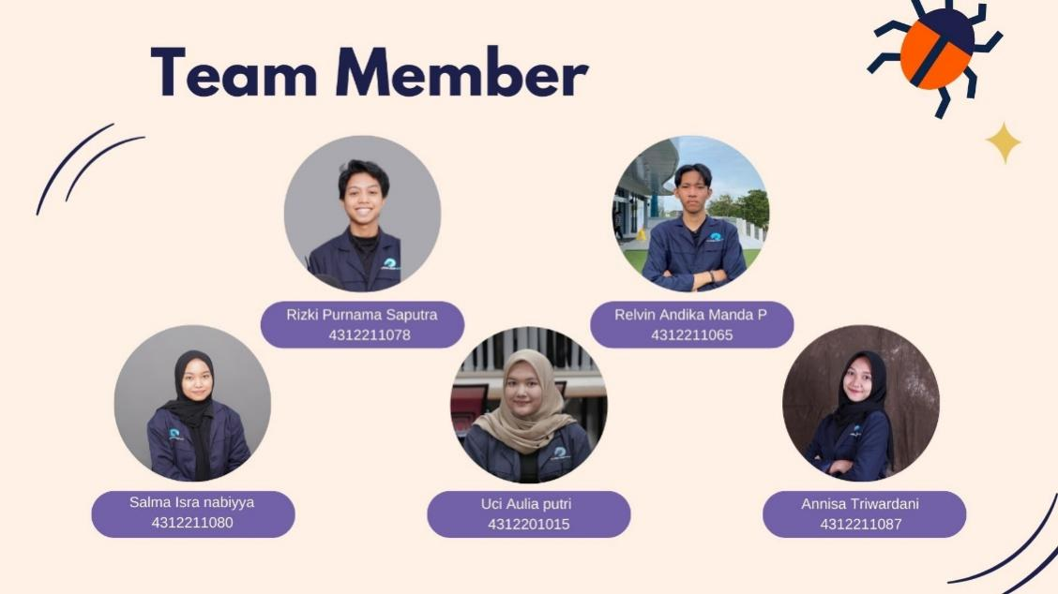

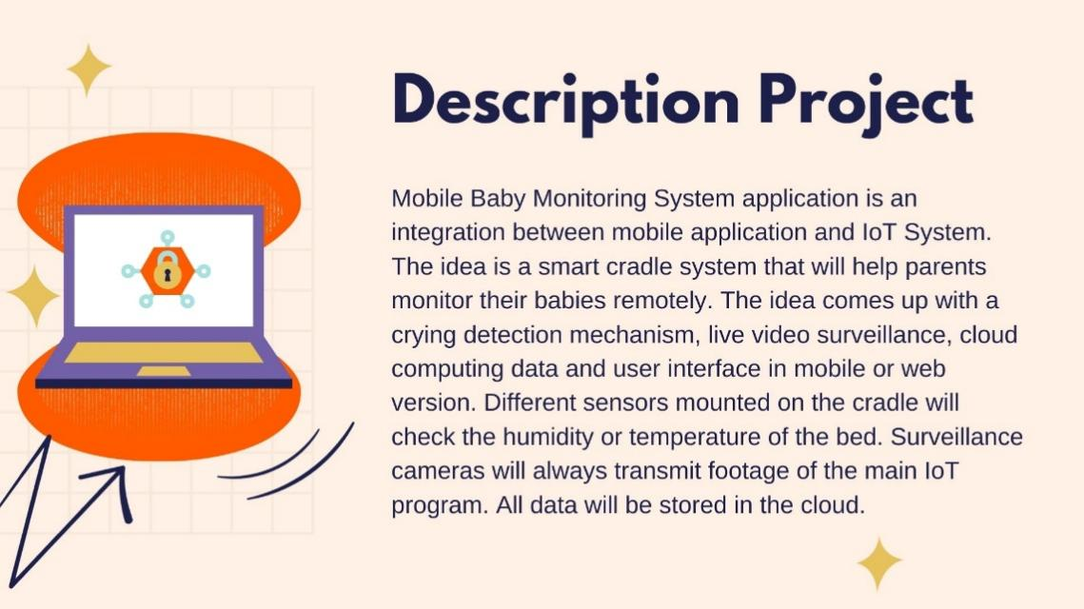

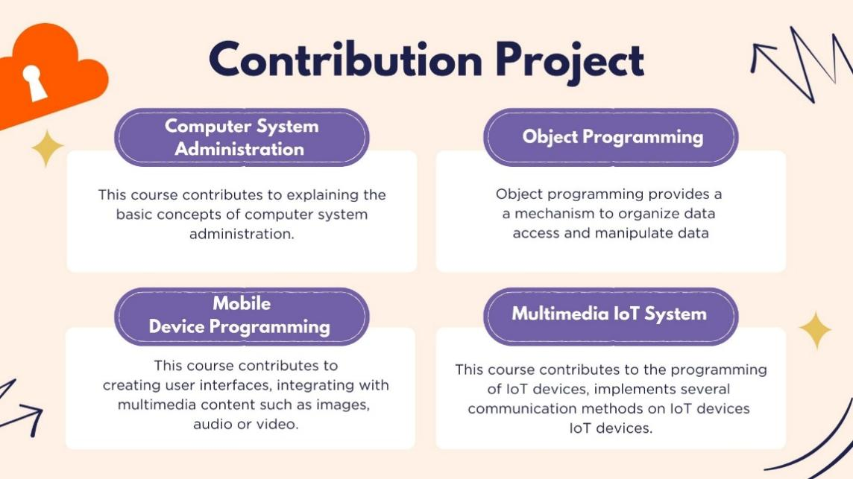

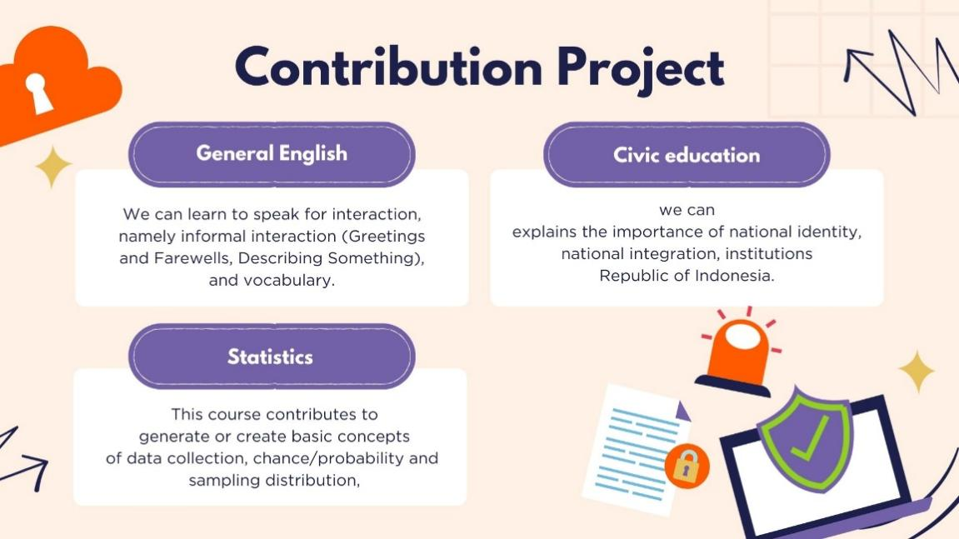

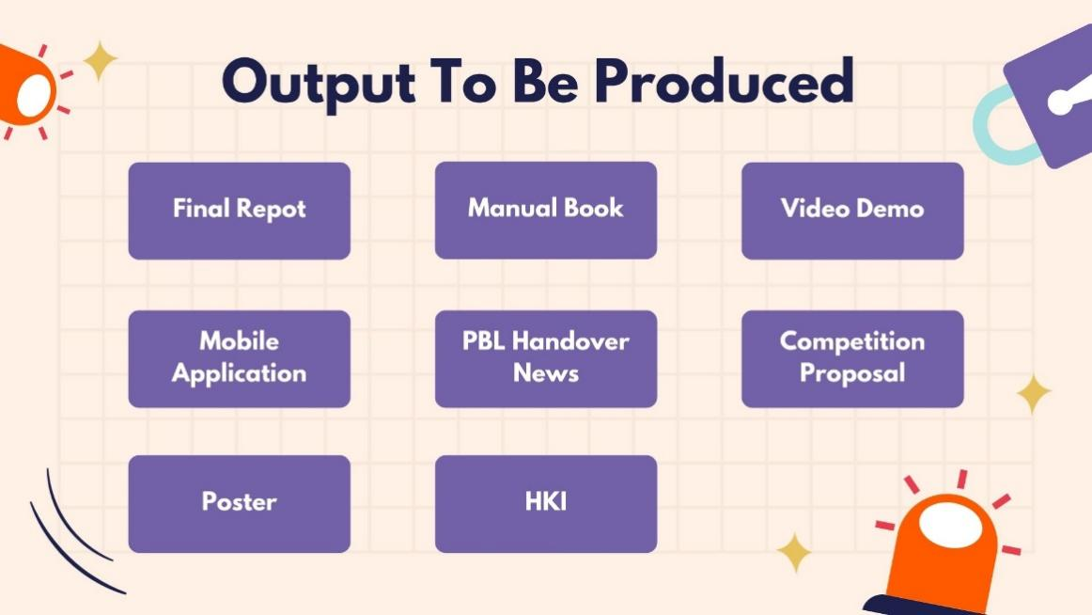

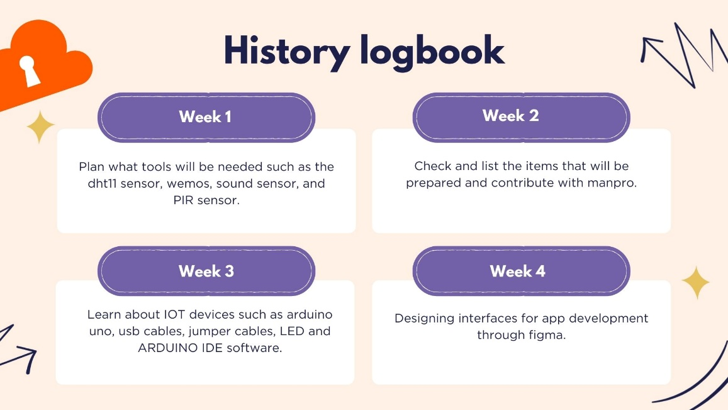

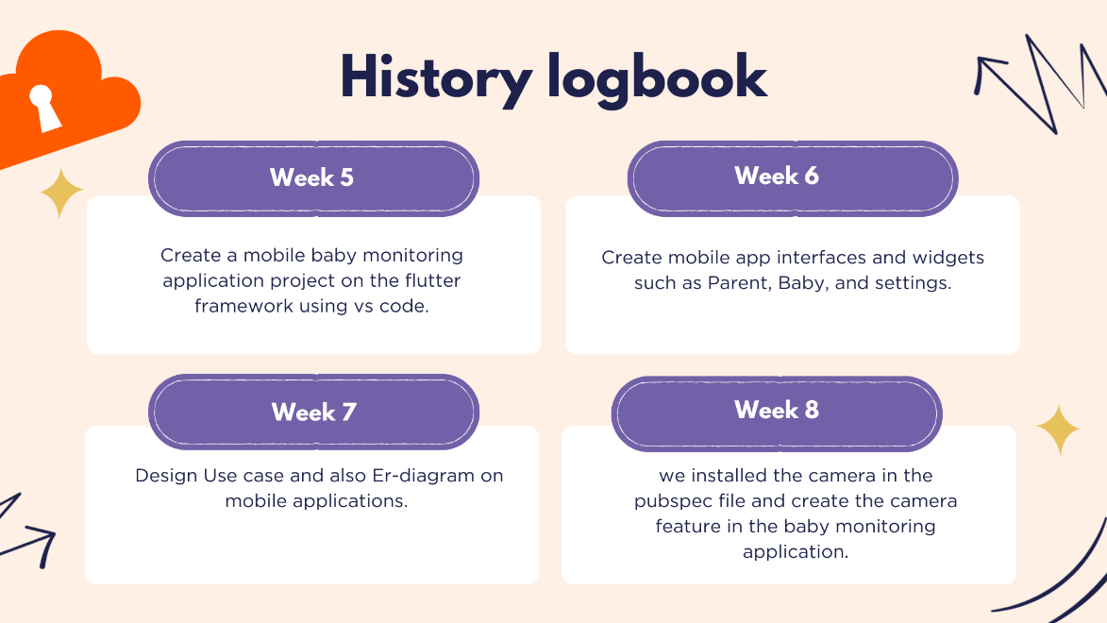

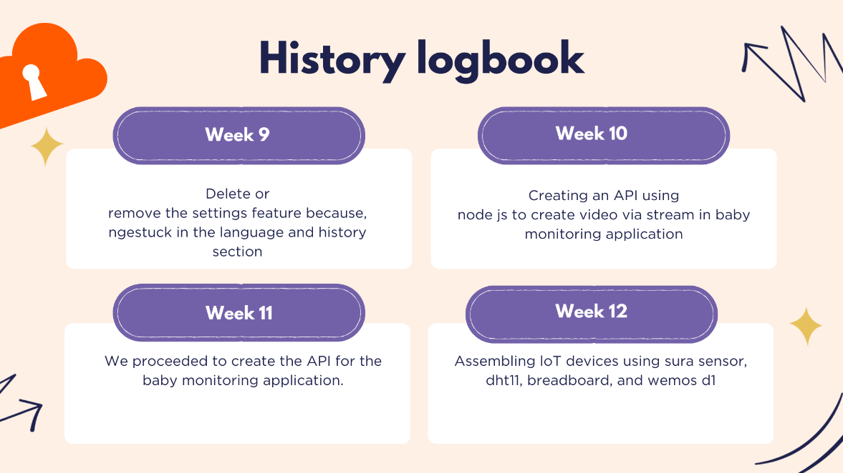

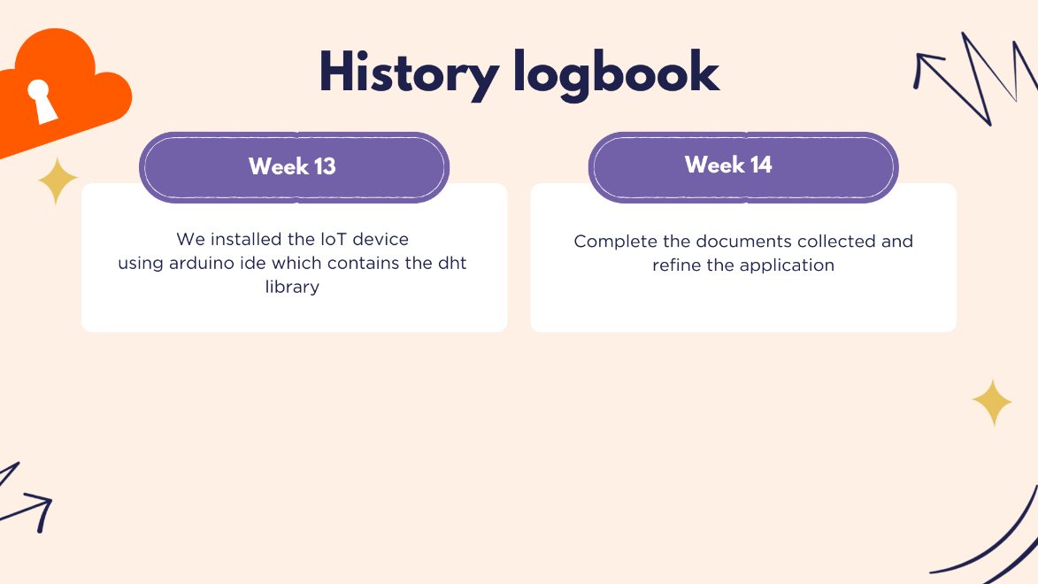

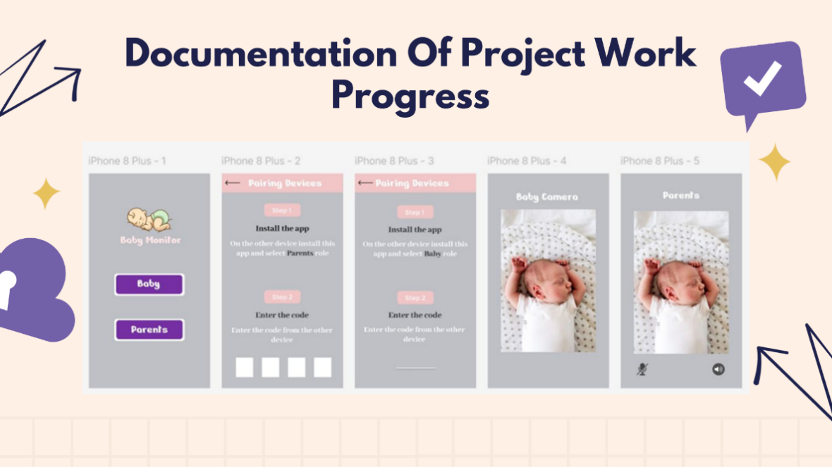

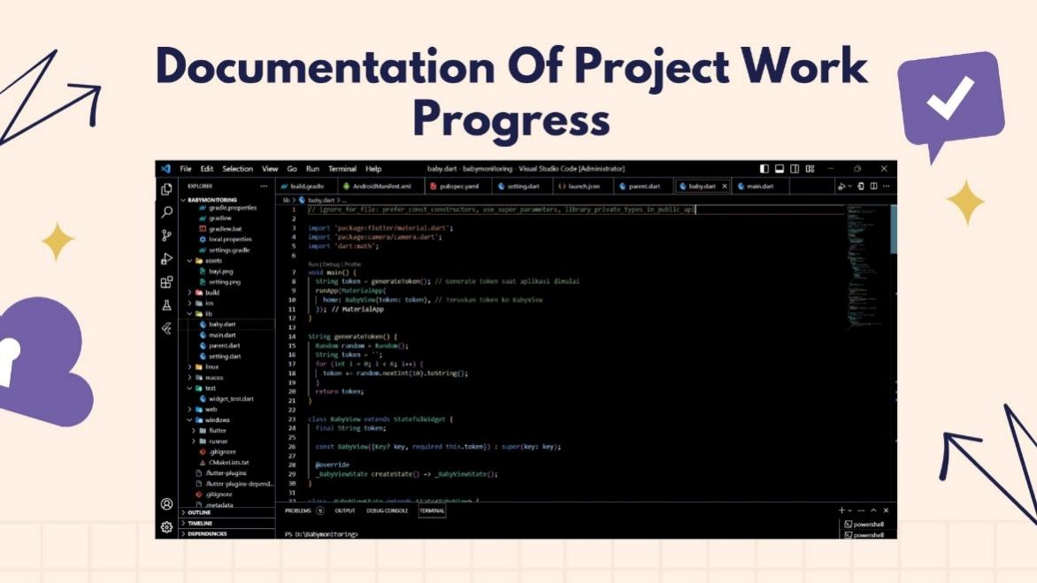

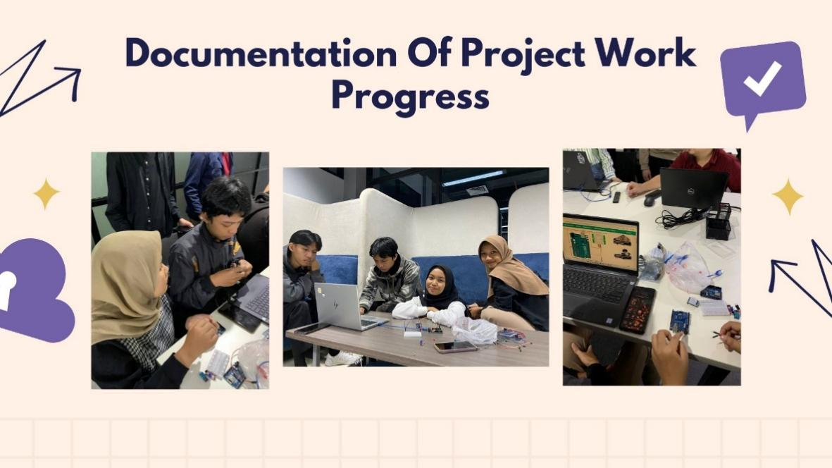

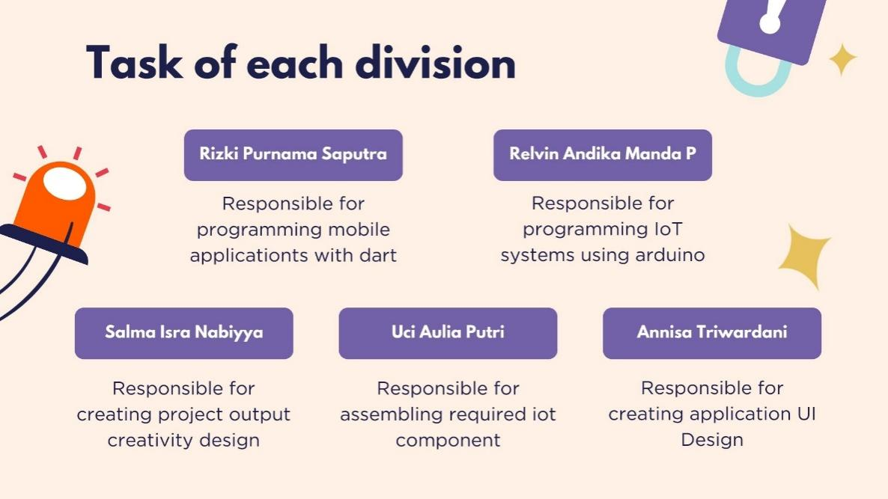

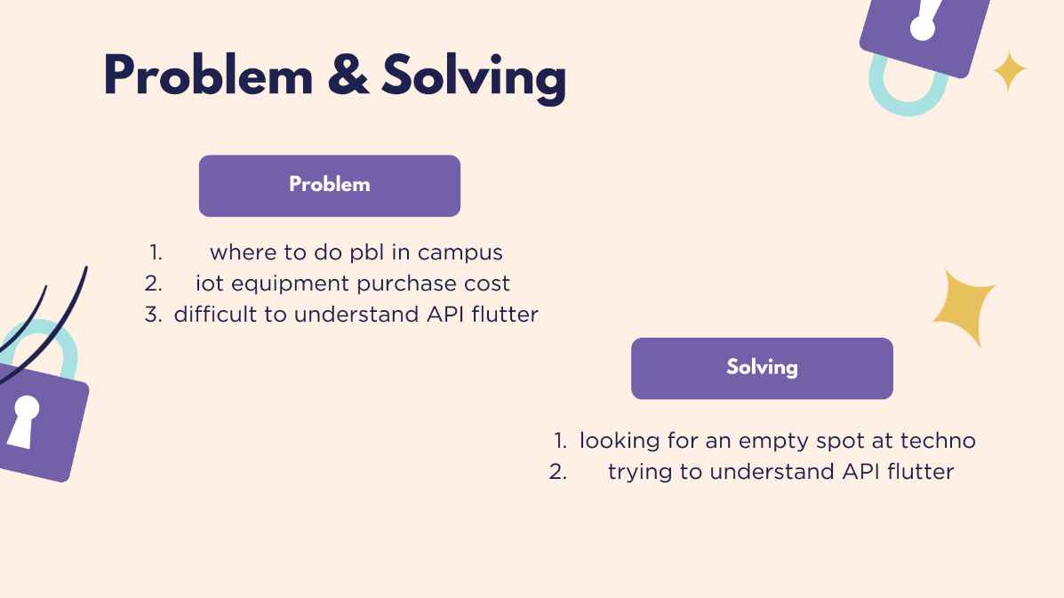

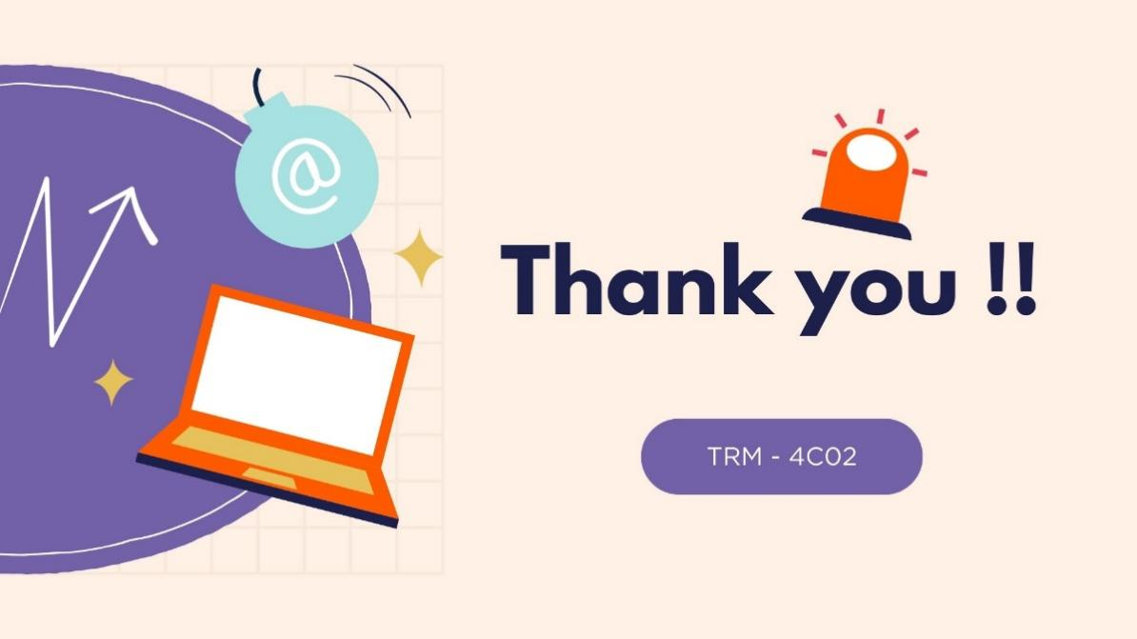

# APPENDIX … – ….

You can add appendices as needed such as:

1. Link of product
2. Link of presentation
3. Link of demo video /teaser
4. Link of scientific poster
5. Link of Intellectual Property Rights Document
6. Link of handover document scan

Make sure the link provided is set up to be accessible to the **public.**

